PURCAHSE ORDERS > RECEIVING ORDERS > COMPLETED ORDERS
- All the tests that I ran in the different order process, with different vendors.
ABF Distribution: Completed the process all the way to completed orders.
Action Meat: I rejected the order and did not send it through approval, so it went to DRAFT
If an order wasn’t approved, it should have the option to:
Send order for approval again
Reject (meaning cancel the Po order completely and move it to completed order as cancelled)
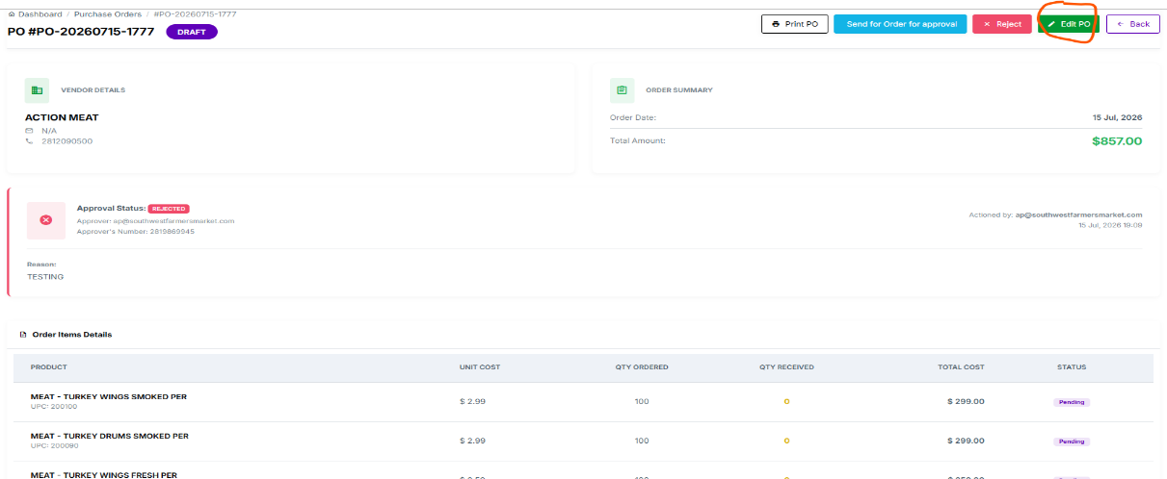
Edit Po (this keeps loading to an error page (500 something went wrong)

Harris county: (tested out the incomplete receipt process) it is currently in received order as IN TRANSIT since not all the items were received.
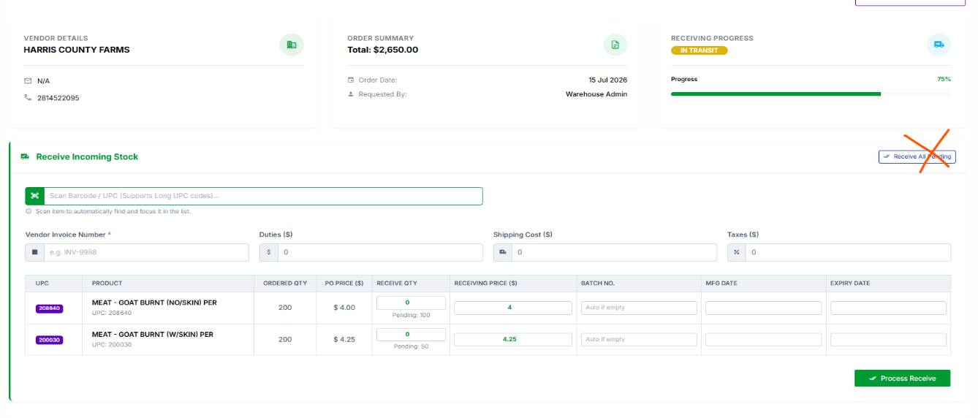
Remove the Receive all pending (we want the person counting the product to really make sure that all the product is RECEVIED and not take an easy way out with this button)

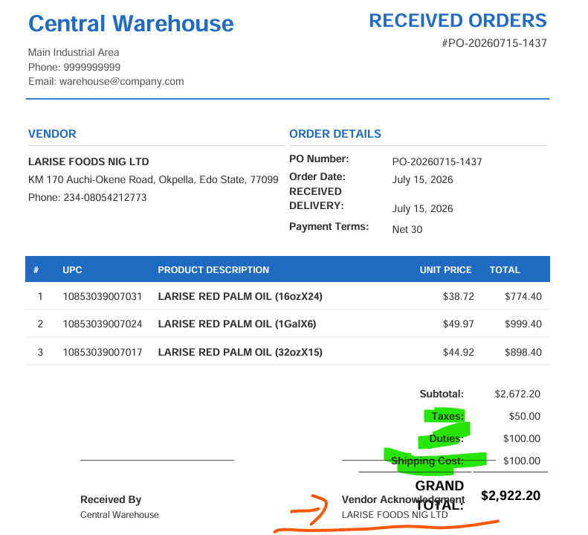
Larise Foods: (with shipping, duties and taxes) the pdf document at the bottom of the paper the vendor acknowledgment is blocked
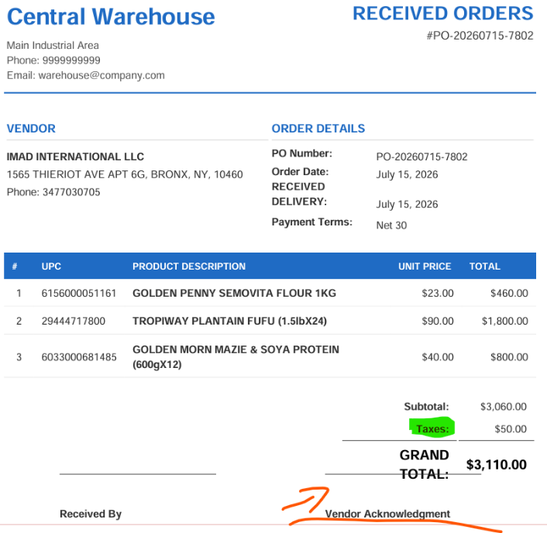
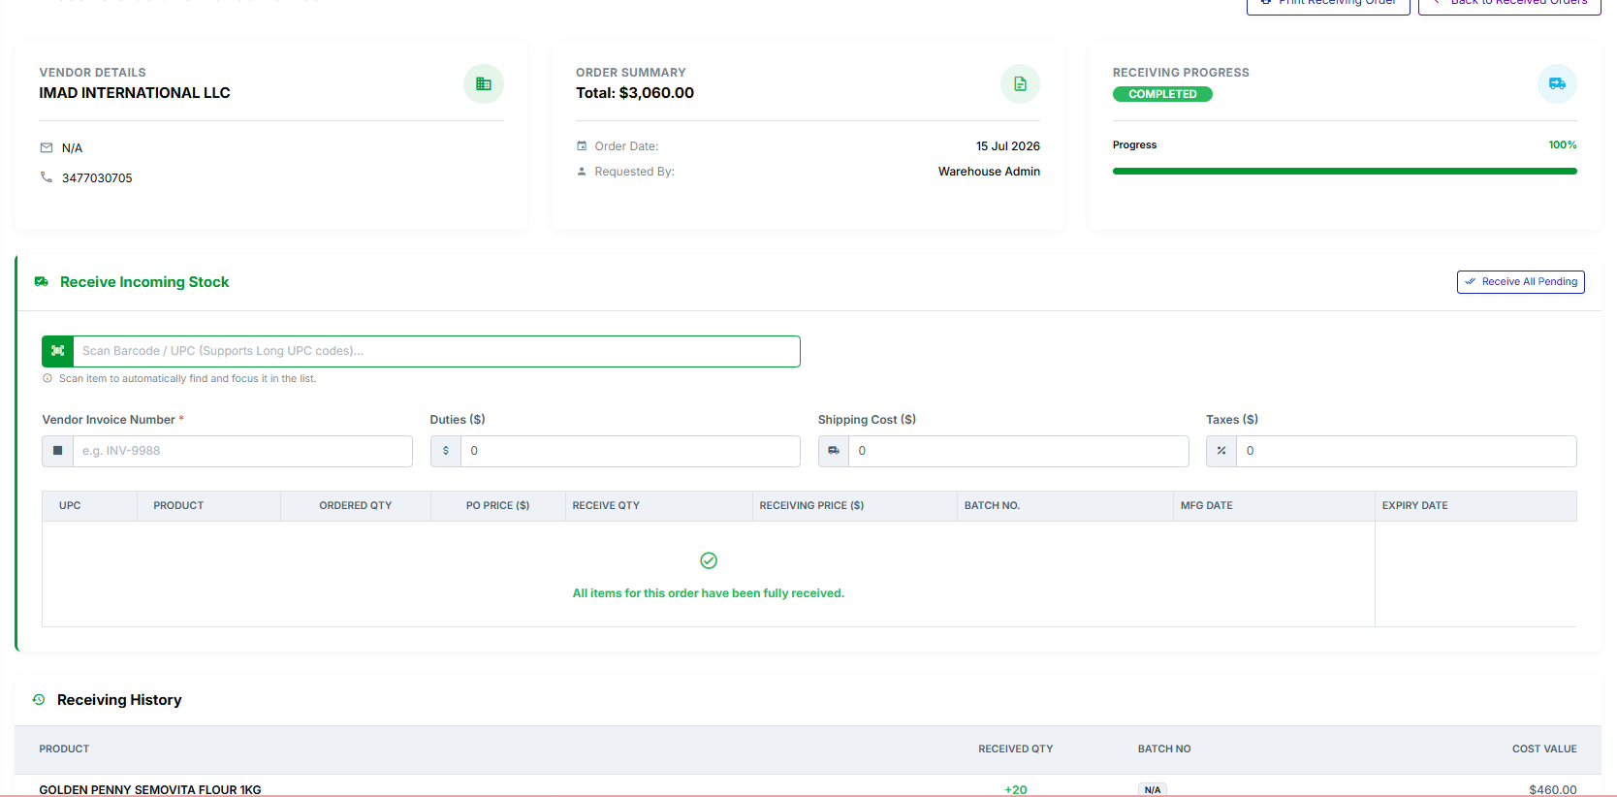
Imad International: (with taxes only) the pdf document at the bottom of the paper the vendor acknowledgment is blocked
COMPLETED ORDERS:
- We should also be able to print from completed orders. (in a case where the person forgets to print the receipt from the orders received)
- Completed orders or Partially completed: in the order summary we should also be able to show if shipping costs were added, duties and taxes. 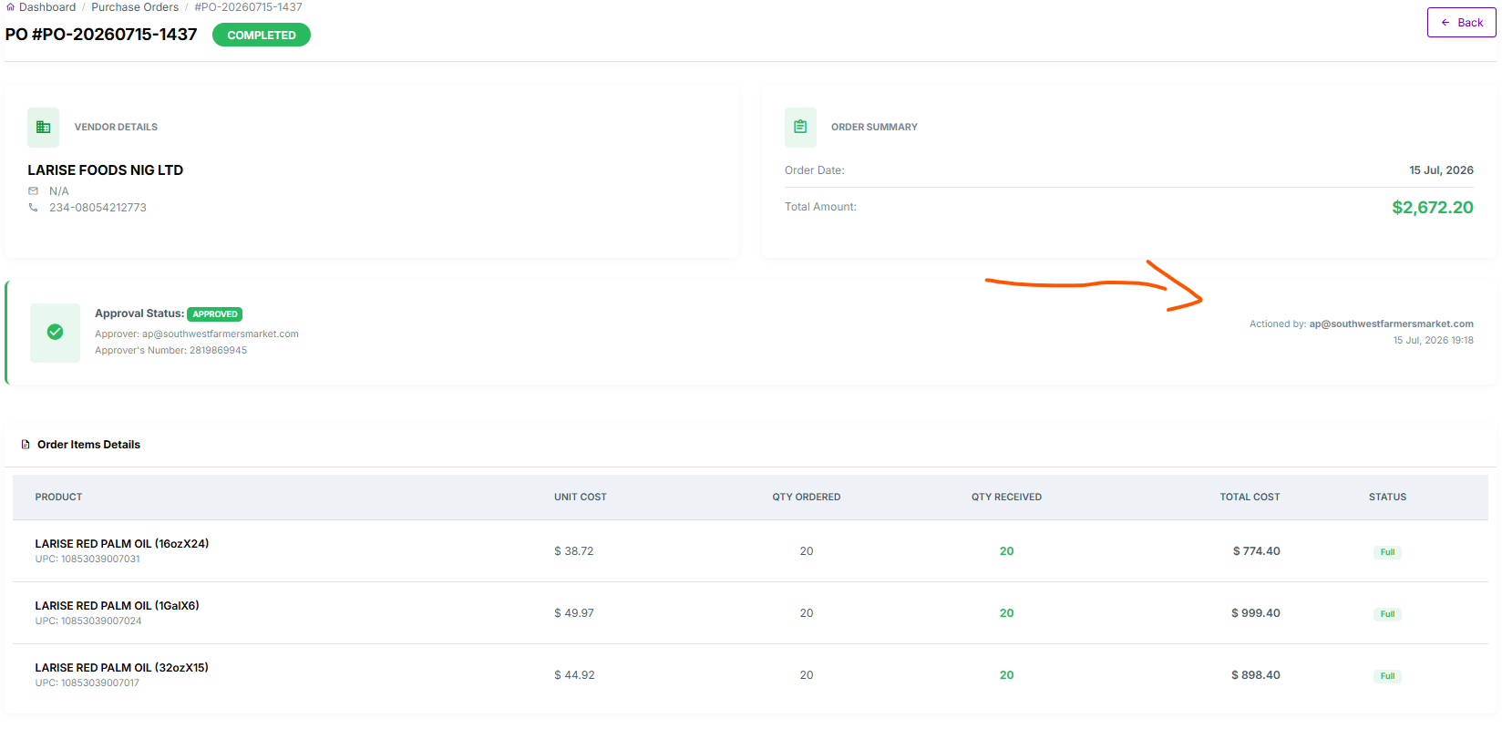
- Also include the vendors invoice number.

NOTE: When recevieing orders and shipping cost, duties and taxes as being added on a partially received order can those number still automatically show that taxes has been added to this receipt and incase if later one in the day we receive only one of the partially received item that shipping cost, duties and taxes should still be there letting the person know that it has already begin added.
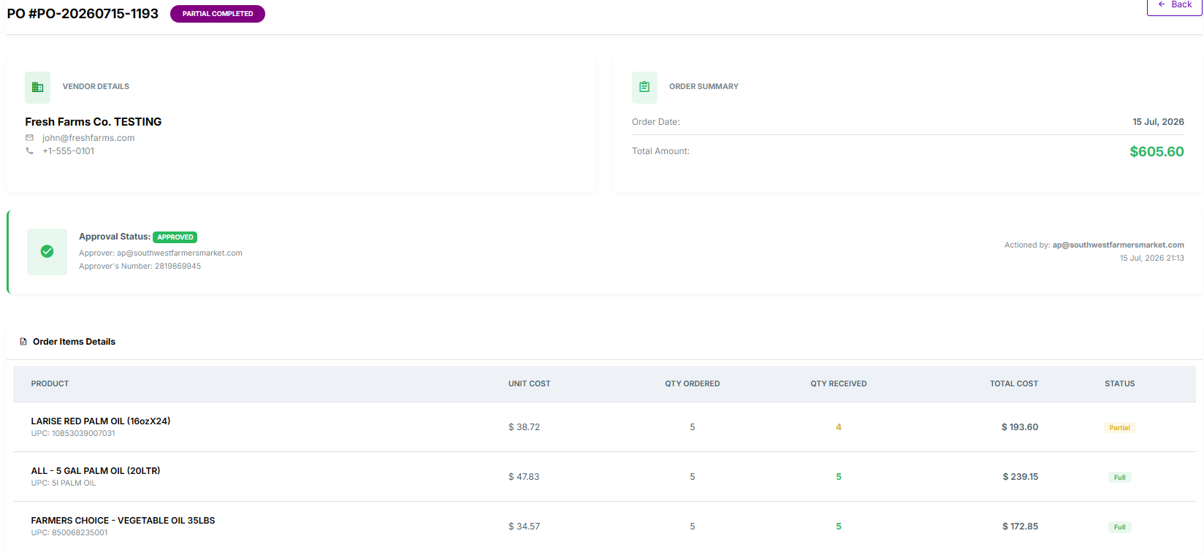
For example: this should have a shipping cost on it but doesn’t.

